Wellington Branch

April 2019 Newsletter
Monthly update | The terror attack in Christchurch on 15 March 2019 was shocking and awful. We wish those who were either injured or lost loved ones, or were the first responders on the day (and the subsequent days) well and hope that with time and support, life will be ok again.  In a recent update, NZISM CEO, Selena Armstrong, talked about the support available to members through its Peer Support Network. Made up of a team of member volunteers, while not trained mental health professionals, they care and are here to listen and provide guidance on a range of issues. Contact details can be found on the NZISM website: https://www.nzism.org/peer-support-network/.  Firewalls  We’re receiving bounce-back emails from tough firewalls who don’t like the group email approach of the Wellington Branch. If you haven’t heard from us lately, please check your junk mail settings and make well.nzism@gmail.com a safe sender. Remember to keep checking the branch page for updates as well.  Emerging Safety Leaders Network  Congratulations to Wellington NZISM member, Josh Dorman, who was recently announced as one of the facilitators on the Emerging Safety Leaders Committee. The newly launched Emergency Safety Leaders Network will initially focus on OH&S professionals who are starting on their professional journey, the network’s intention is to provide NZISM members and non members the opportunity to engage with and learn from their peers. We look forward to hearing more about what the Network has planned and will be inviting them to make use of the monthly timeslots the Wellington NZISM Branch has set aside for seminars.
Review of last event | Tuesday 2 April – 2.00-3.00pm  Visit to Stuff Petone Print Site, 35 Bouverie Street, Petone – by Josh Dorman  I thoroughly enjoyed showing our fellow members around our Petone Print Site. We did this late in the afternoon so we were able to see live production.  After equipping ourselves with the appropriate PPE, I was able to show a few projects we did to improve safety on complex machinery such as pre-press and publishing equipment. We started in pre-press showcasing our brand new platemakers, moved up and down our multistory press and went through our publishing and distribution centre.  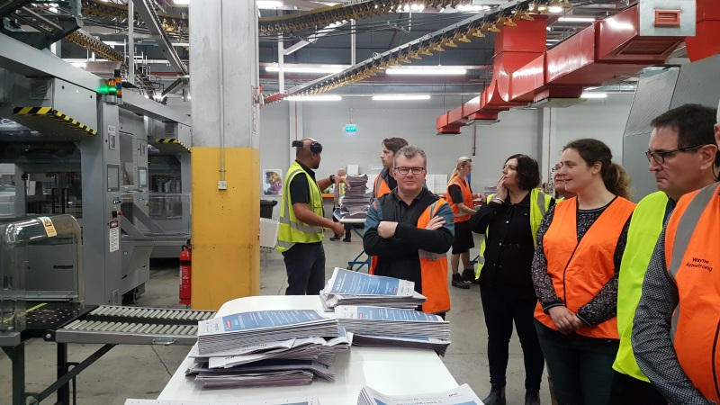  Any other members who didn't have the opportunity to visit are more than welcome to contact me for a viewing.
May event  12.30-1.30pm  Wellington Branch AGM  National Library  Molesworth Street | Recognising that everyone’s time is valuable, the committee have decided to hold the AGM on the day scheduled for our normal monthly seminars. We’ve delayed the start till 12.30pm to allow for a Business Leaders’ Health and Safety Form which is finishing at 12.00pm. Please feel free to bring your lunchbox with you. Tea, Coffee and water will be available on the day.  Greg Dearsley, NZISM President, is our guest speaker. Greg will present the new rules that will be submitted for vote at the National AGM.  Three roles will be voted on at the Wellington Branch AGM; Branch Manager, Branch Secretary and Branch Treasurer.  For the committee to be effective, we need between 6-8 people to help spread the load. Each member chooses 1-2 months of the year where they will be responsible for organising the seminar. The committee ‘meets’ virtually via Zoom once a month for about 30-45mins to go over planning for the seminars and discuss any other matters that may need decisions, so taking part is kept simple.  An agenda and nomination papers will be distributed shortly by email.
Local H&S scene / What’s going on | Research into awareness around worker exposure to hand-arm vibration in the workplace – in case you missed it, the last newsletter from the CEO included an invitation from Steph Hembury of Canterbury Branch to complete a short 10 question survey related to awareness and control of exposure to Hand Arm Vibration.  Steph anticipates the survey will remain open throughout April closing on 31 April. She will then analyse the information and provide feedback at a later date.  You can find the article and link to the survey here.  Philip Aldridge, the Executive Director of HASANZ, has asked us to make our members aware of the H&S Professionals Pipeline Project Survey.  Co-funded by HASANZ and WorkSafe New Zealand, the project aims to understand the current capability (knowledge, skills, experience and pathways to practice) and capacity across multiple health and safety disciplines. This will inform recommendations that will ensure the health and safety disciplines can meet expected demand for services in 10 years’ time.  As NZISM Wellington Branch provides support to those who work in a health and safety discipline in New Zealand, Philip has asked if we could forward the link to the survey to our members, so that they can contribute to the project. No identifying details will be used in any analysis or reporting from this survey.  The survey will be open for 3 weeks, closing on the 26th April.  https://www.surveymonkey.com/r/SB9Q2FW  If you have any questions please contact Helen Parkes on Helen@cosmanparkes.co.nz or 021 833 377. HASANZ will of course be sharing the report with the findings with us all!  Women in Safety have announced their next Group Event on Monday 27 May 2019 alongside the SafeGuard conference.  They will be showcasing the different approaches to safety engagement, leadership and influencing using emotional intelligence. This event is proudly sponsored by the New Zealand Institute of Safety Management (NZISM).  Spaces are limited - please RSVP to margaret@vshealthandsafety.co.nz by 30th April 2019. Further information about the speakers is attached with this email.  Details are out for this year’s Safeguard Conference on 28-29 May 2019 in Auckland.  NZISM Webinars  You can access NZISM webinars you may have missed by logging on to the Members only page on the NZISM website.  If you’d like to promote an event or share information that would be of interest to NZISM members, please email well.nzism@gmail.com.
Other Information | Contact information  A reminder to ensure your profile on the NZISM website – https://www.nzism.org is up to date. The success of the Wellington branch relies on the input of its members and our ability to send communications to you.
Important stuff to know | Wellington monthly events are scheduled for the first Tuesday of every month at The National Library, Thorndon. Keep an eye on the NZISM calendar on the website for more information.  A reminder also to check out our neighbouring regions’ events on the NZISM Calendar. There may be something on in another Branch that is relevant to you.

